FOSE3000 – Kinetic Pathways

You’ve likely been to a shopping centre or transit station during peak hours and noticed the volume of people going about their business at the same time. For each step you and the others around you take, energy is wasted into the ground with no way to recover it. Kinetic Pathways are a way to generate power from high foot traffic areas, by using tiles that utilize electromagnetism to recover that lost energy. Our goal is to help address the UNSDG Goal 7, aiming to create affordable and clean energy.

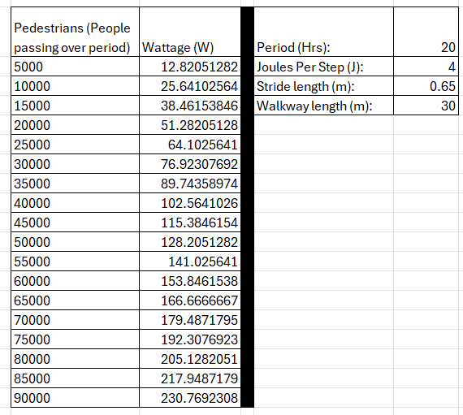Kinetic Pathways have a 5 to 10mm travel distance, as the tile is depressed it moves a magnet through a coil, inducing a current in the coil and generating a current. Each step can generate anywhere from 2 to 4 joules of energy depending on the weight of the person. This energy is used to charge batteries during peak traffic hours and used to power streetlights, low power appliances, or fed directly back to the grid.

Accounting for average foot traffic data, stride length, and joules per step, a 30m strip of kinetic pathway can generate on average between 100W to 300W. Power output is determined by pedestrian weight, stride length, and number of steps taken on the pathway.

The difference in execution between the proposed project and existing installations is scale. Many existing installations from companies such as Pavegen are very limited in scope, with relatively small and poorly positioned installations that fail to take advantage of high foot traffic areas. With a more strategic approach the amount of power generated can be maximized, implementing them in busy streets, business centres, airports, train stations, and other high foot traffic locations.

There are already a number of installations in various locations around the world. Powering the lights for local football fields in Brazil and Nigeria; phone charging stations in Telford UK; the Cesis Space Centre in Latvia; and many other installations in public and private locations.

Another aspect of this technology is feedback given to pedestrians. Small low-power displays can be used to display the power generated, giving feedback to users and letting those walking by know that they’re making a difference. Installations in schools can be used to teach students about electromagnetism and the importance of sustainability.

Our 12-month plan includes trial installations of a 30m by 5m strip of Kinetic Pathway in locations such as Circular Quay, the Sydney Opera House, Macquarie University Central Courtyard, and the entertainment quarter next to the SCG.

Following success in these locations, scope could be expanded to major promenades such as Barangaroo, locations in Manly, and potentially working with private companies to offer installations in places such as Westfield locations and high traffic business centres.

# References

* Visconti, P., Bagordo, L., Velázquez, R., Cafagna, D. and De Fazio, R., 2022. Available technologies and commercial devices to harvest energy by human trampling in smart flooring systems: A review. *Energies*, *15*(2).
* Cuneo, B., Exploring the Potential of Pavegen’s Kinetic Energy Generating Floor for Sustainable Energy Solutions: A Proposal for Cal Poly SLO.
* Kelly, C. (2022) *CBD series: Sydney targets high streets for revival*, *Ragtrader*. Available at: https://www.ragtrader.com.au/news/cbd-series-sydney-targets-high-streets-for-revival#:~:text=In%20both%20autumn%202020%20and,foot%20traffic%20in%20the%20CBD. (Accessed: 02 March 2024).
* Australian Bureau of Statistics., 2013. ‘Pedometer steps’, Australia Health Survey: Physical Activity.
* Markets & Markets., 2023. Energy Harvesting Markets by Technology - Global Forecast to 2028
* Lyon, D., 2022. *Energy Harvesting: Pavegen and the Rise of Kinetic Tile Tech*. Available at: https://theswitch.co.uk/energy/guides/technology/energy-harvesting-tiles#kinetic-tile-cost (Accessed: 02 March 2024)
* *Walking counts - City of Sydney* (no date) *City of Sydney*. Available at: https://www.cityofsydney.nsw.gov.au/public-health-safety-programs/walking-counts (Accessed: 03 March 2024).